Process Flow to Make Payment to the University Through Samarth Portal
Go to https://cup.edu.in

Click on Fee Payment (as shown in the following screen)
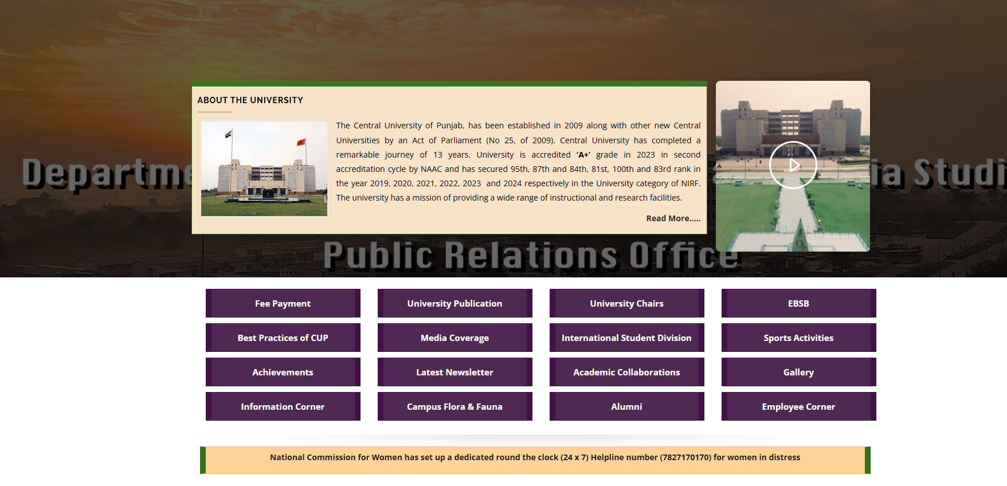

Choose your Fee Category from two categories available on the screen by Clicking on "Click Here to Pay"
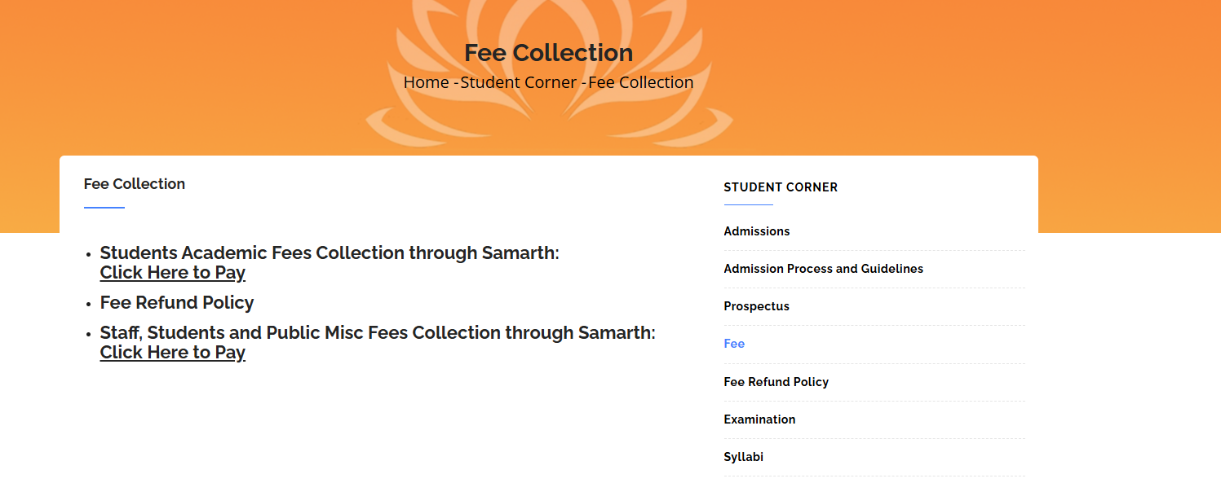

Click on Ok on the Following screen
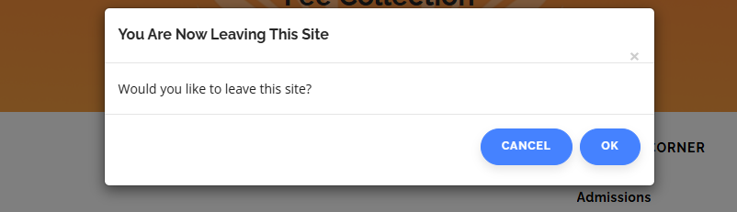

Choose appropriate Fee Portal depending on Your Fee Category / payment type
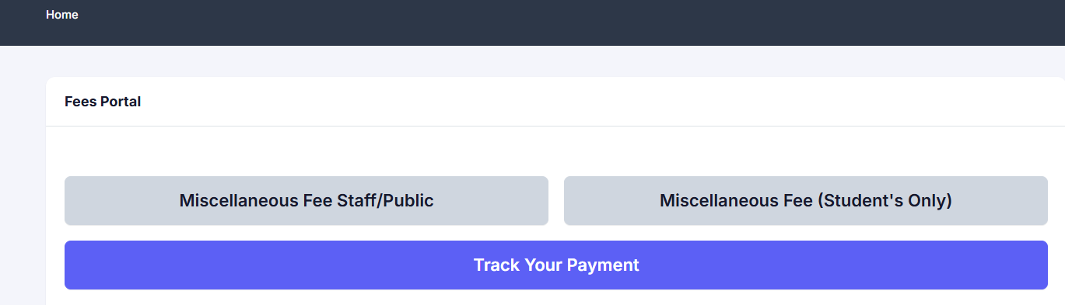

Fill any of the Form (as generated as per your previous click choice) and Click on Save
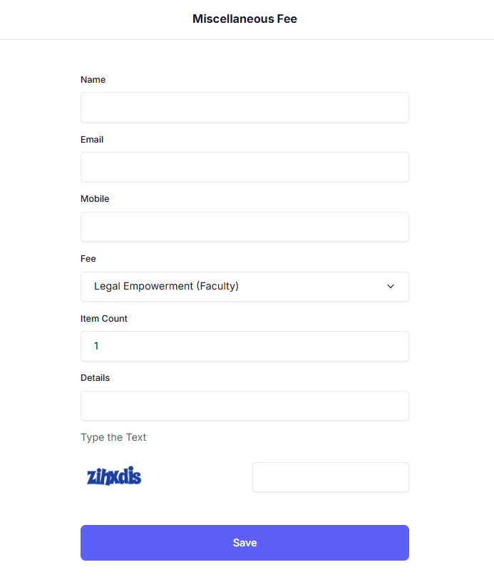
Or
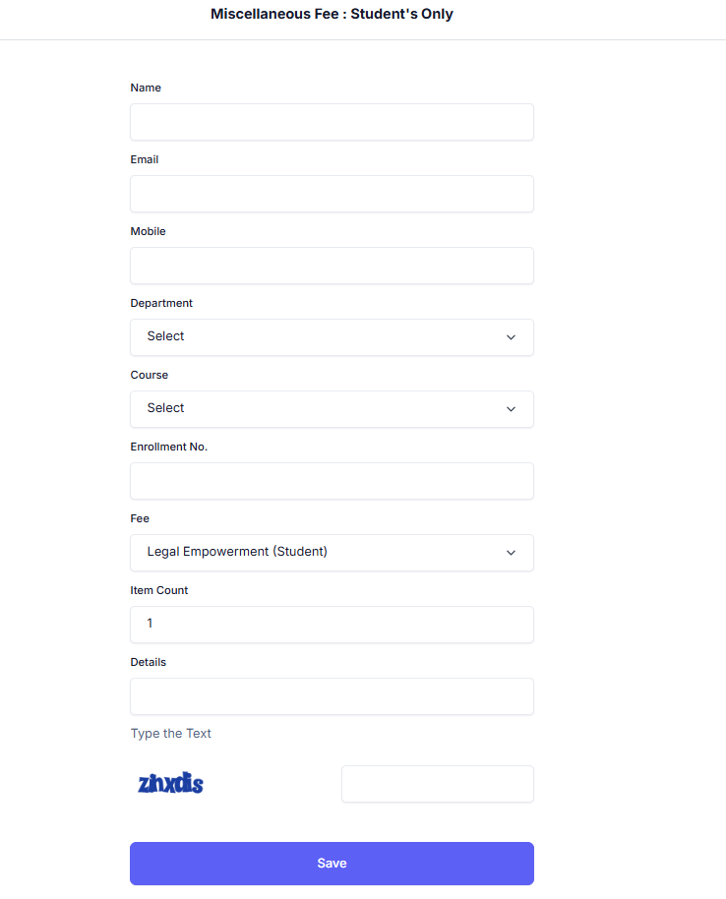

Enter OTP and Proceed
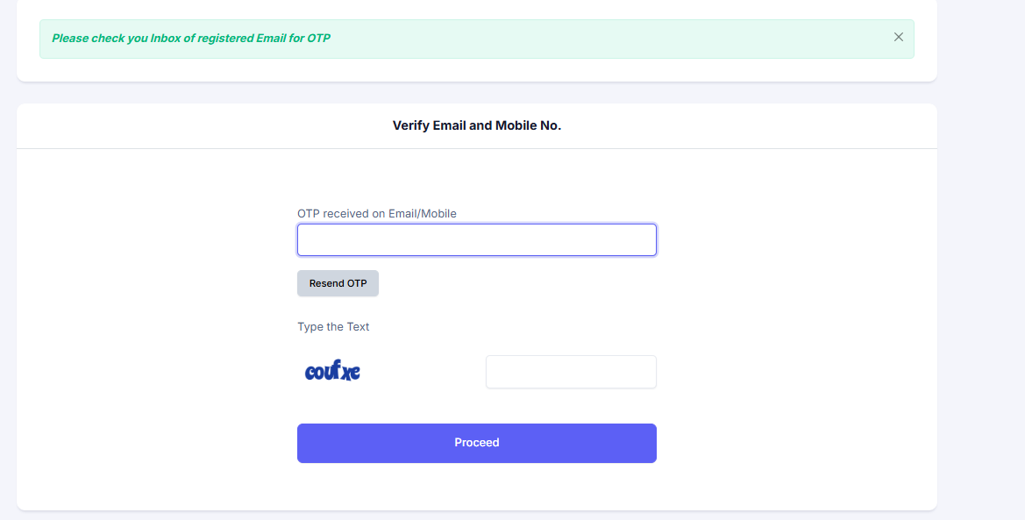

Click on "Pay Fees" Button under Action Tab
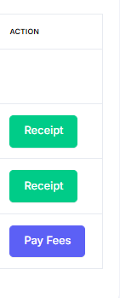

Click on "Proceed to Pay: Click here to payment" Button



Make the Payment as per Desired Option (Fill the optional columns as mandatory to get SMS of payment)

After successful payment following message will appear

Fill Details

Enter Otp To verify Email and Mobile No. (Click on proceed)
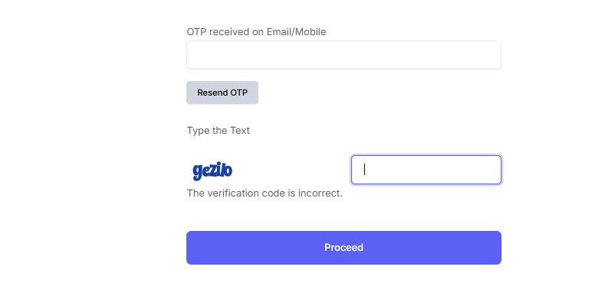

Click on Receipt against the concerned payment.
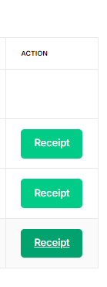
The receipt will be generated. Print receipt (if required). You can also generate receipt at anytime as per the method described above from the step "Track Your Payment".
Thanking you

