How to Create Bill in the Samarth Portal (Single Bill/Invoice/Request for Advance)
- Submitting / entering a bill for payment/request for advance by the Department User

1. Bill Creator will login to the portal at https://cup.samarth.ac.in/index.php/site/login

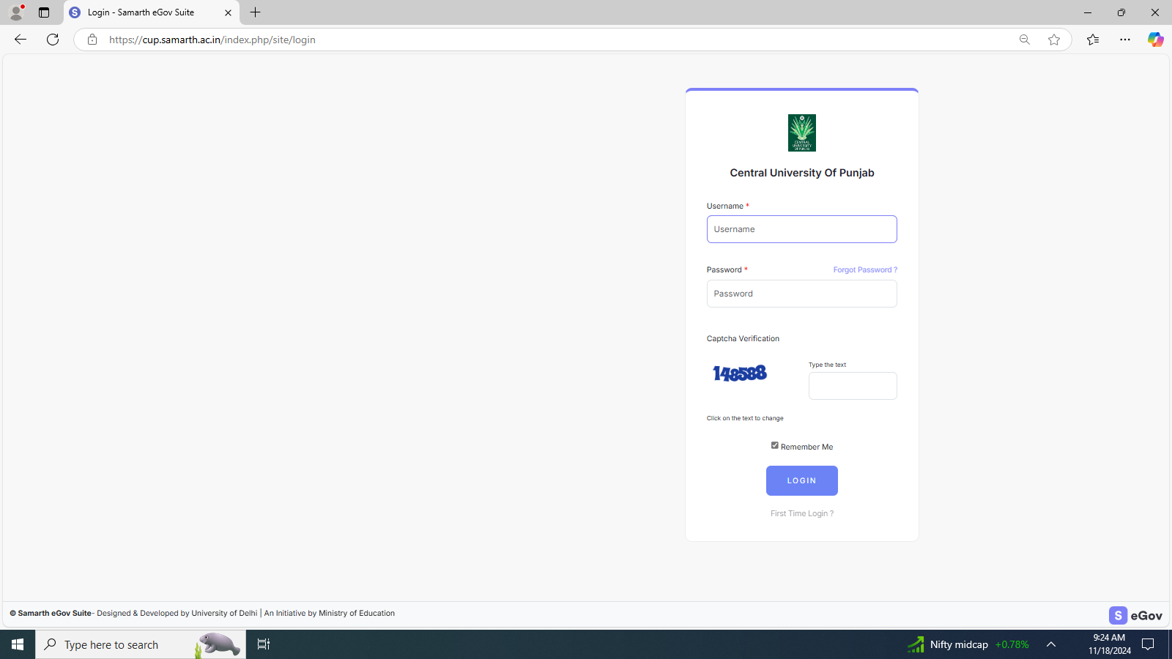
2. Click on Finance
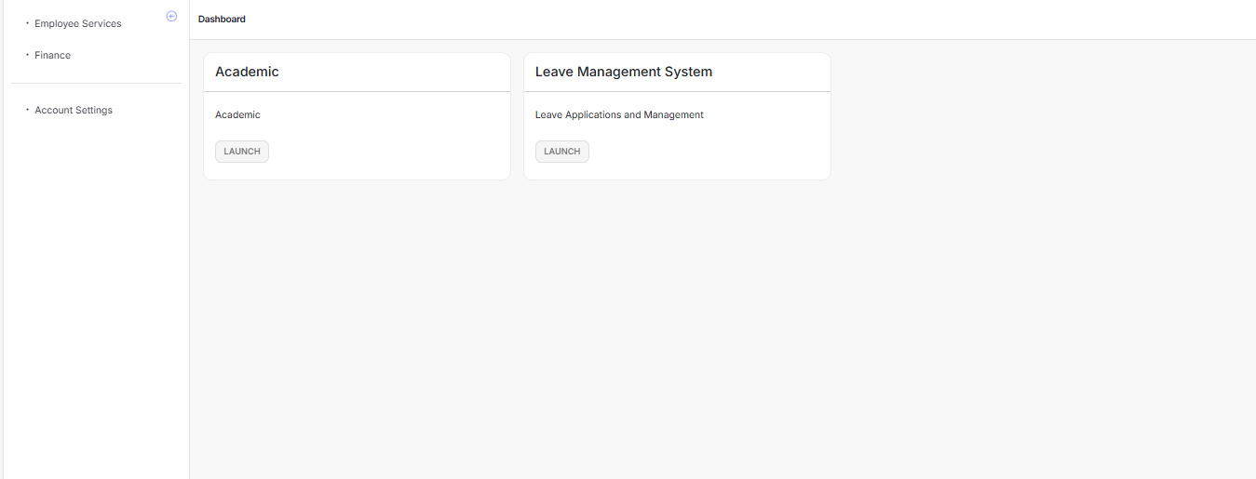
3. Click on Manage Vendor Bill Payment under Bill Tracking
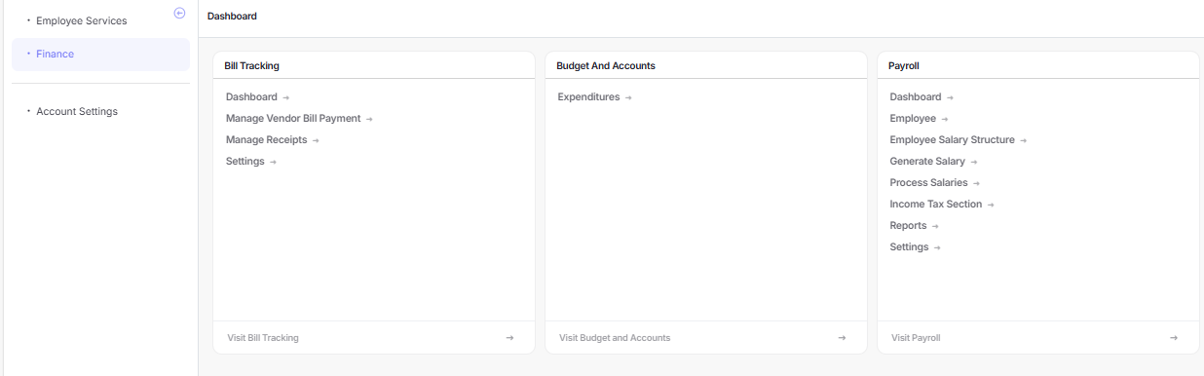

Click on "Add New Vendor Bill" under Manage Vendor Bills Panel
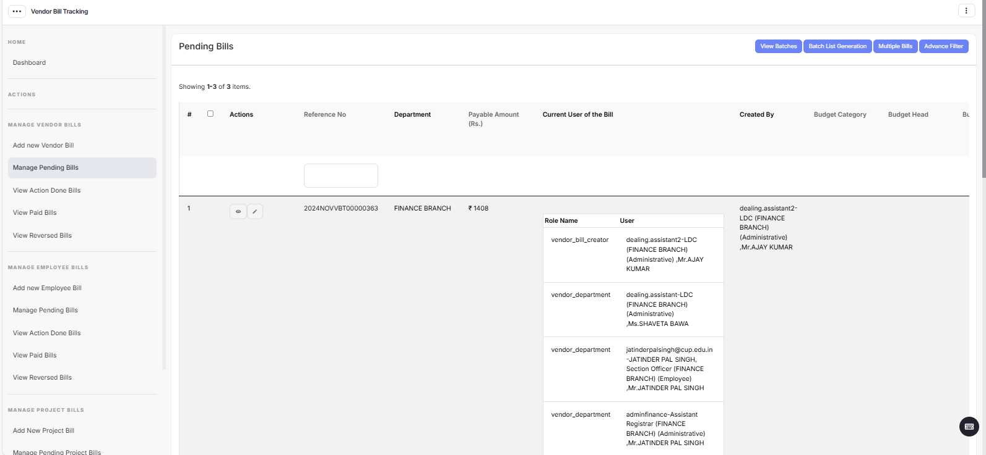
Click on "Add Bill" in Blue color on right corner of the screen (for one vendor)
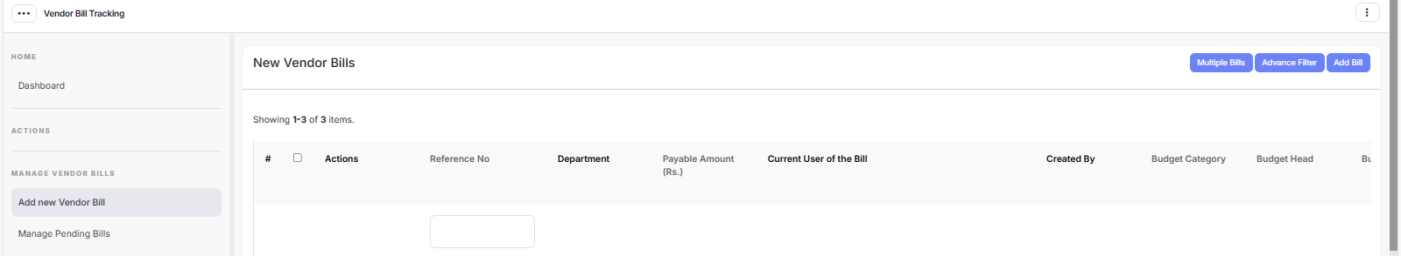
Fill the Add Bill Format
Select Finance Branch in the Organizational Unit
Select the Bill type (Recurring / Non Recurring)
Select the Financial Year : 2024-25
Click on "Skip Purchase Order" button
Select Vendor
Fill complete Bill details as follows:
Click “No” against Do you want vendors to verify the GST ?
Select type of payment
Enter Bill No.
Enter Bill Date
Upload the Bill (with gate entry and stock entry proof on it)
Enter Bill amount without tax (e.g. for a Bill of Rs. 118/- with Rs. 100/- as taxable amount i.e. amount without tax and CGST 9% and SGST 9% Rs. 18/- taxes are added, please enter Rs. 100/- at this stage)
Choose the taxes levied in the bill at "Applicable Taxes"
Match the total tax amount on Bill at Invoice Amount
Choose Deduction Category (Percentage Based or Amount Based) as applicable and make the deductions in the following manner.
Income Tax TDS and GST TDS are separate deductions.
- Income Tax TDS is deducted @ 2% of taxable amount in the bill i.e. the amount without Taxes (on Services bills Only) (e.g. You are entering a bill of Rs. 118 in which Rs. 100/- is taxable amount and after adding 18% of GST (i.e. 9% CGST and 9% SGST) the gross value of Bill is Rs. 118/-). In this case Rs. 2/- (2% of 100/- shall be deducted as Income Tax TDS. If the bifurcation is not made in the bill of taxable amount and taxes, please do the calculation as per the rate of taxes entered in the bill.
- GST TDS is deducted @ 2% of the taxable bill amount i.e. amount without tax, only if the Bill amount is Rs. 250000/- or above. (applicable on all bills– both Goods and Services). This is also applicable if the bill is below Rs. 250000/- but the contract/purchase order is of Rs. 250000/- or above. The method of deduction will remain same as explained in Income Tax TDS.
- Deduct late delivery charges @ 0.5% per week on the taxable amount. A week is counted on its start (i.e. for 1 day also) E.g. For 1-7 days a full week shall be counted and for 8-14 days two full weeks shall be counted and so on.
Single / all above deductions may be applicable in one bill as per circumstances.
Fill the rest of the format completely.
Match the details entered with the Bill / relevant documents.
Click on save.
Message will come " Bill recorded successfully" and the entered Bill shall be displayed on top.
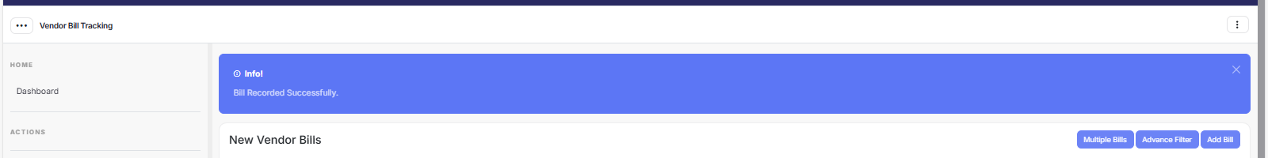

Now the Bill has been recorded successfully. A reference number in the form of 2024XXXVBT0000XXXX shall generate.
Enter / record this reference number on the file and mention that the “Bill has been entered on the Samarth Portal” and sign it. Thereafter, move the file as per existing procedure going on in the University.

In case of any difficulty contact Mr. Abhishek (79860-96572) or Mr. Deepak, Assistant (94642-93354).

