How to Add Multiple bills on Samarth Portal (If the file contains more than one invoice or single invoice containing more than one rates of GST)
- Bill creator will login to SAMARTH PORTAL. (https://cup.samarth.ac.in)
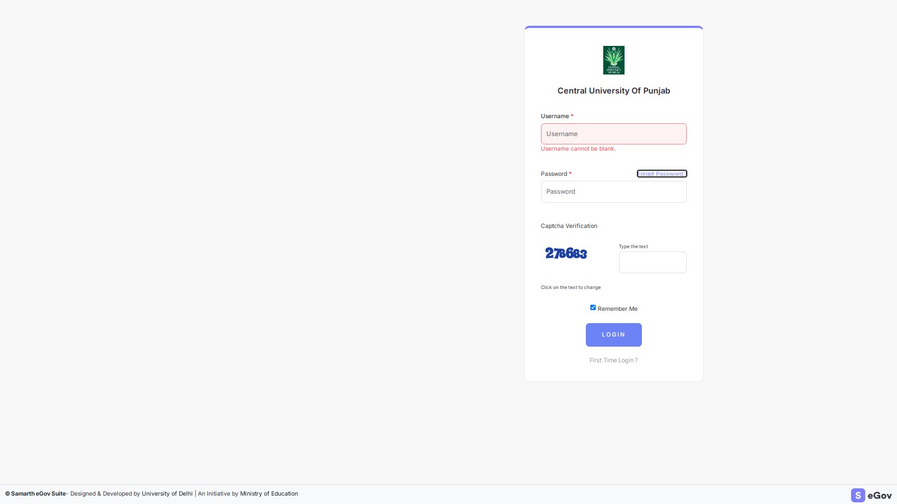

- Click on FINANCE.

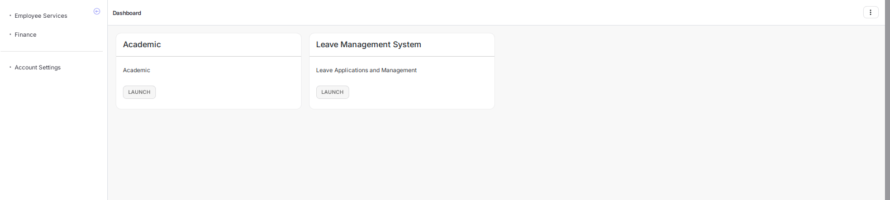

- After that, Choose MANAGE VENDOR BILL PAYMENT. (under Bill tracking)

- Place The Click On “ADD NEW VENDOR BILL” under Manage Vendor Bills Panel

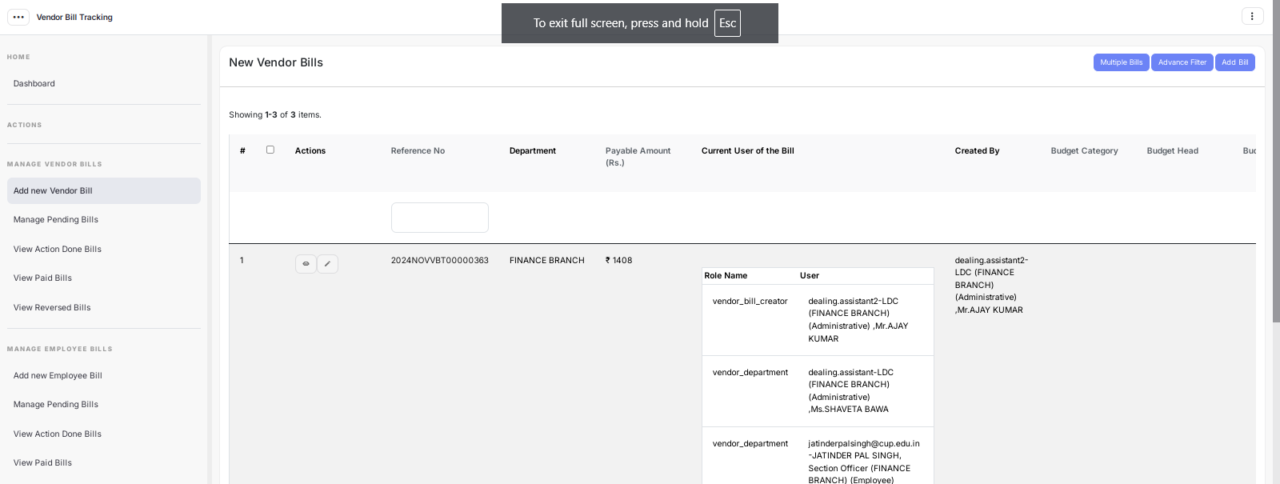

- Click on Tab named “Multiple Bills” in Blue color. (On the Right-Top corner of Screen)

- Then, ADD MULTIPLE BILL (for different rates of GST for each vendor) as per following process. :
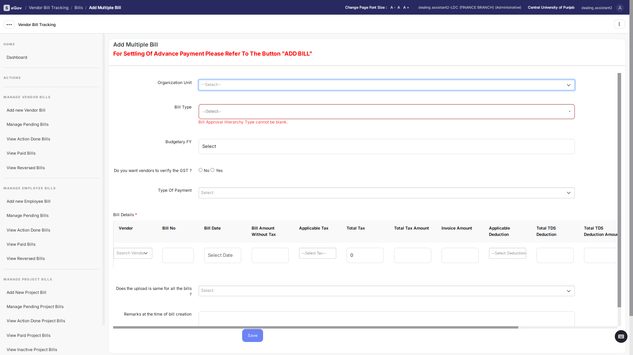

Fill The Above mentioned details and after entering one entry click on ‘+’ button on right side of the screen.
Process for entering one bill out of multiple bills / one GST Component in single bill having multiple GST Rates on above given screen
- Choose Organization Unit : Finance Branch (in all bills of Recurring and Non-Recurring except Project Bills)
- Bill Type - Recurring / Non-recurring as applicable
- Budgetary F.Y. - 2024-25
- Click on ‘NO’ AGAINST “Do you want vendors to verify the GST ?”
- Type of payment - Choose as applicable from the drop down list.
- Then Fill Bill Details/advance details/part payment details as applicable.
- Make the deductions as follows for Income Tax TDS, GST TDS and Late Delivery charges (as applicable)
Income Tax TDS and GST TDS are separate deductions.
- Income Tax TDS is deducted @ 2% of taxable amount in the bill i.e. the amount without Taxes (on Services bills Only) (e.g. You are entering a bill of Rs. 118 in which Rs. 100/- is taxable amount and after adding 18% of GST (i.e. 9% CGST and 9% SGST) the gross value of Bill is Rs. 118/-). In this case Rs. 2/- (2% of 100/- shall be deducted as Income Tax TDS. If the bifurcation is not made in the bill of taxable amount and taxes, please do the calculation as per the rate of taxes entered in the bill.
- GST TDS is deducted @ 2% of the taxable bill amount i.e. amount without tax, only if the Bill amount is Rs. 250000/- or above. (applicable on all bills– both Goods and Services). This is also applicable if the bill is below Rs. 250000/- but the contract/purchase order is of Rs. 250000/- or above. The method of deduction will remain same as explained in Income Tax TDS.
- Deduct late delivery charges @ 0.5% per week on the taxable amount. A week is counted on its start (i.e. for 1 day also) E.g. For 1-7 days a full week shall be counted and for 8-14 days two full weeks shall be counted and so on.
Single / all above deductions may be applicable in one bill as per circumstances.

- Click YES (If the upload is same for all the bills)
- Then, Upload in a single PDF - Bill, purchase order, admin and financial approval (in PDF format or JPEG)
- Write Remarks.
- SAVE The Bill.

Now the Bill has been recorded successfully. A reference number in the form of 2024XXXVBT0000XXXX shall generate.

Enter / record this reference number on the file and mention that the “Bill has been entered on the Samarth Portal” and sign it. Thereafter, move the file as per existing procedure going on in the University.

In case of any difficulty contact Mr. Abhishek (79860-96572) or Mr. Deepak, Assistant (94642-93354).

