User Manual for STP

Step 1: Registered yourself on https://mmc.ugc.ac.in portal.
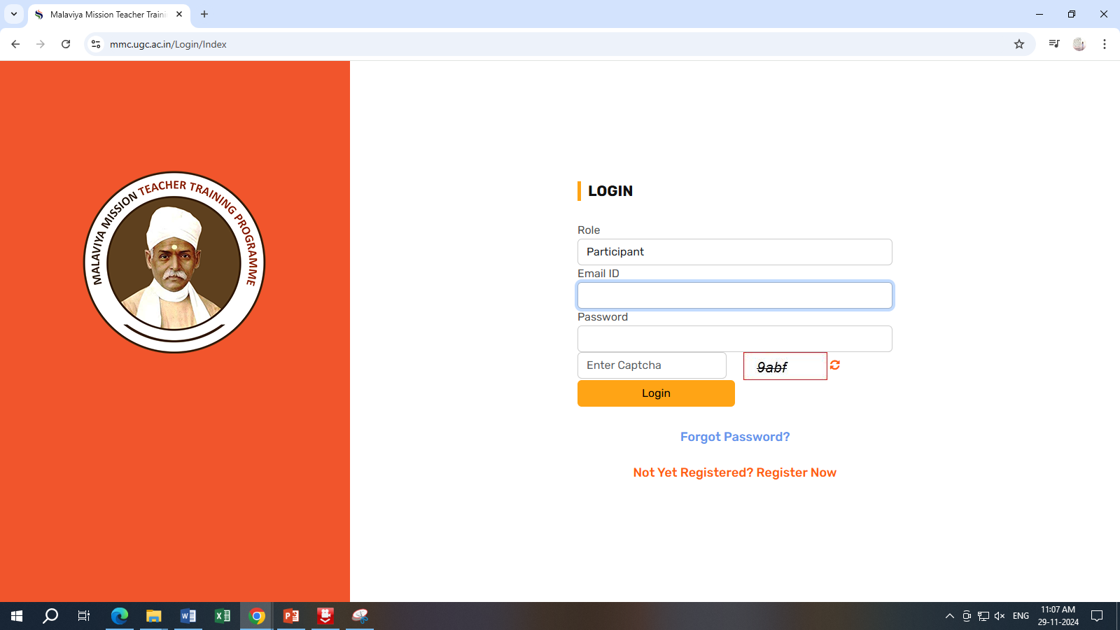

Step2: Enter your details and Click on Submit.
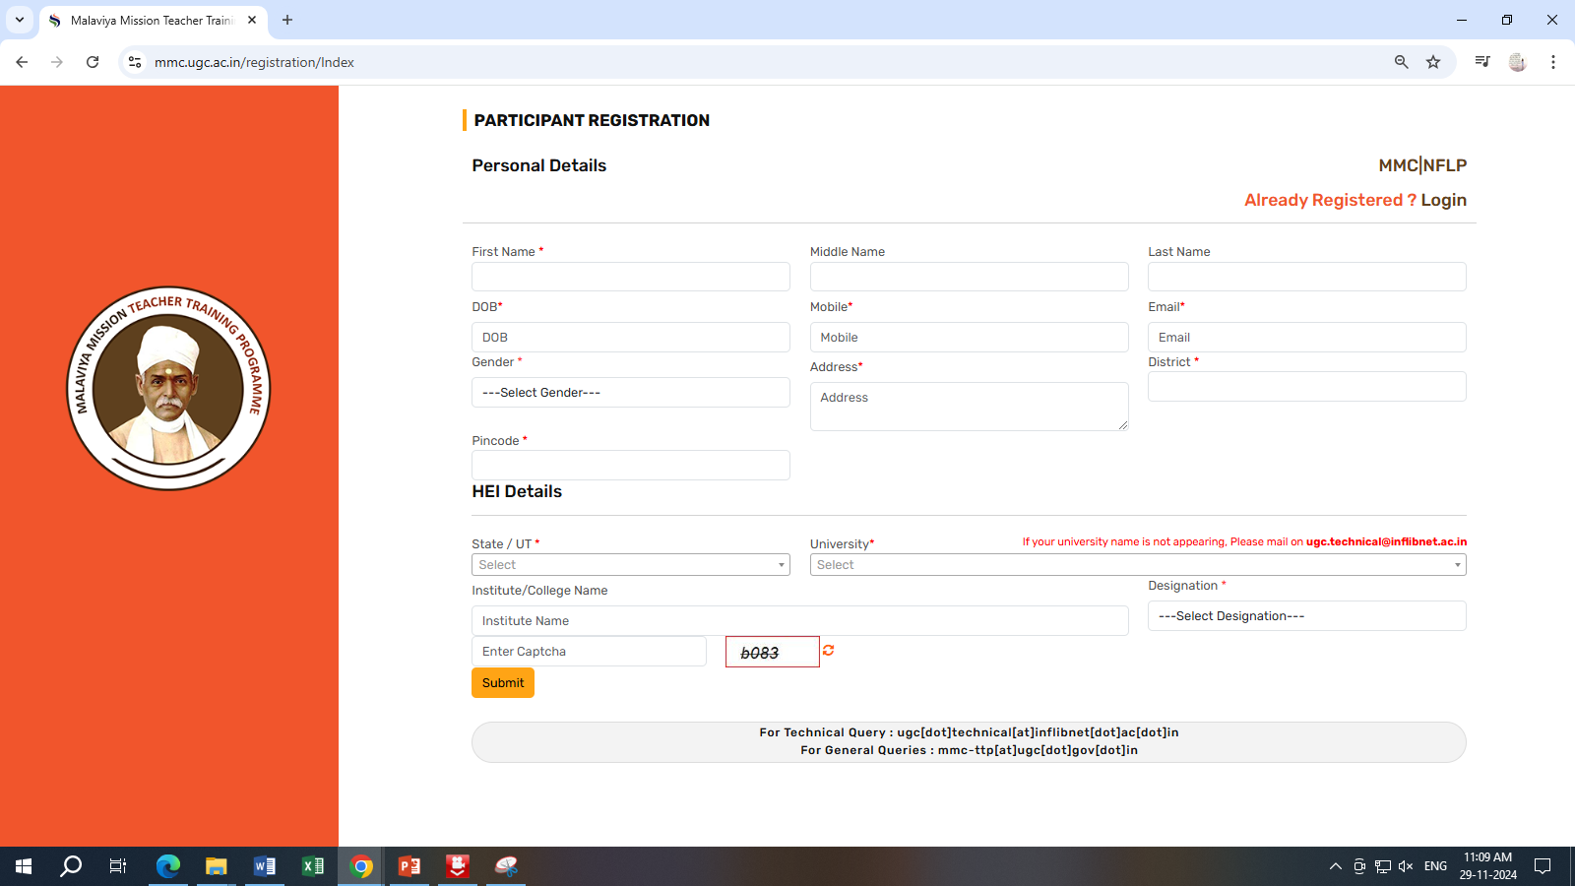

Step 3: Check your email Inbox/Junk Email where you receive the Username & Password and Change your password.
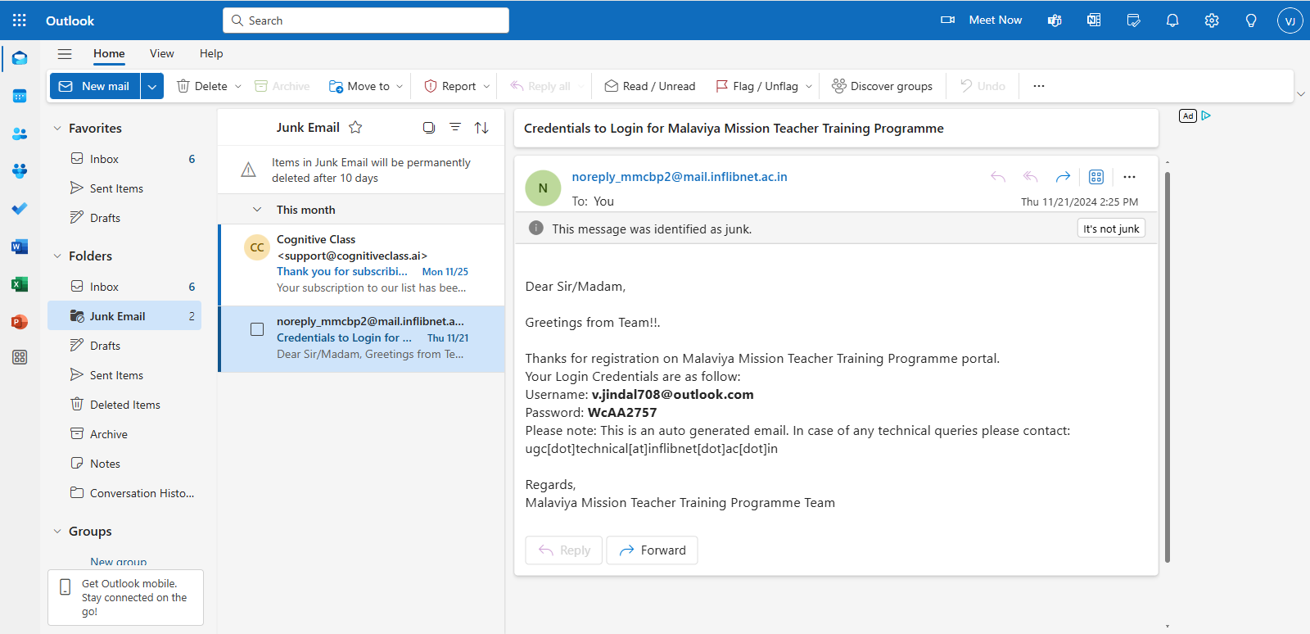

Step 4: Kindly Complete your Profile and Submit.
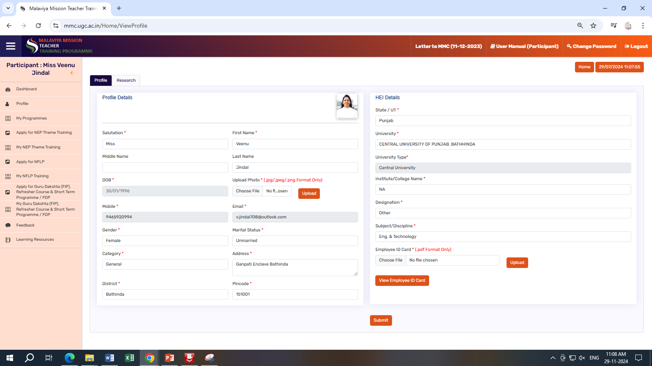

Kindly Upload your Photo and Employee ID Card as mentioned above.
It’s menditory for the Apply in any programme.

Step 5: Click on “Apply for Guru Dakshta (Faculty Induction Programme), Refresher Course and Short Term Programme / Faculty Development Programme”
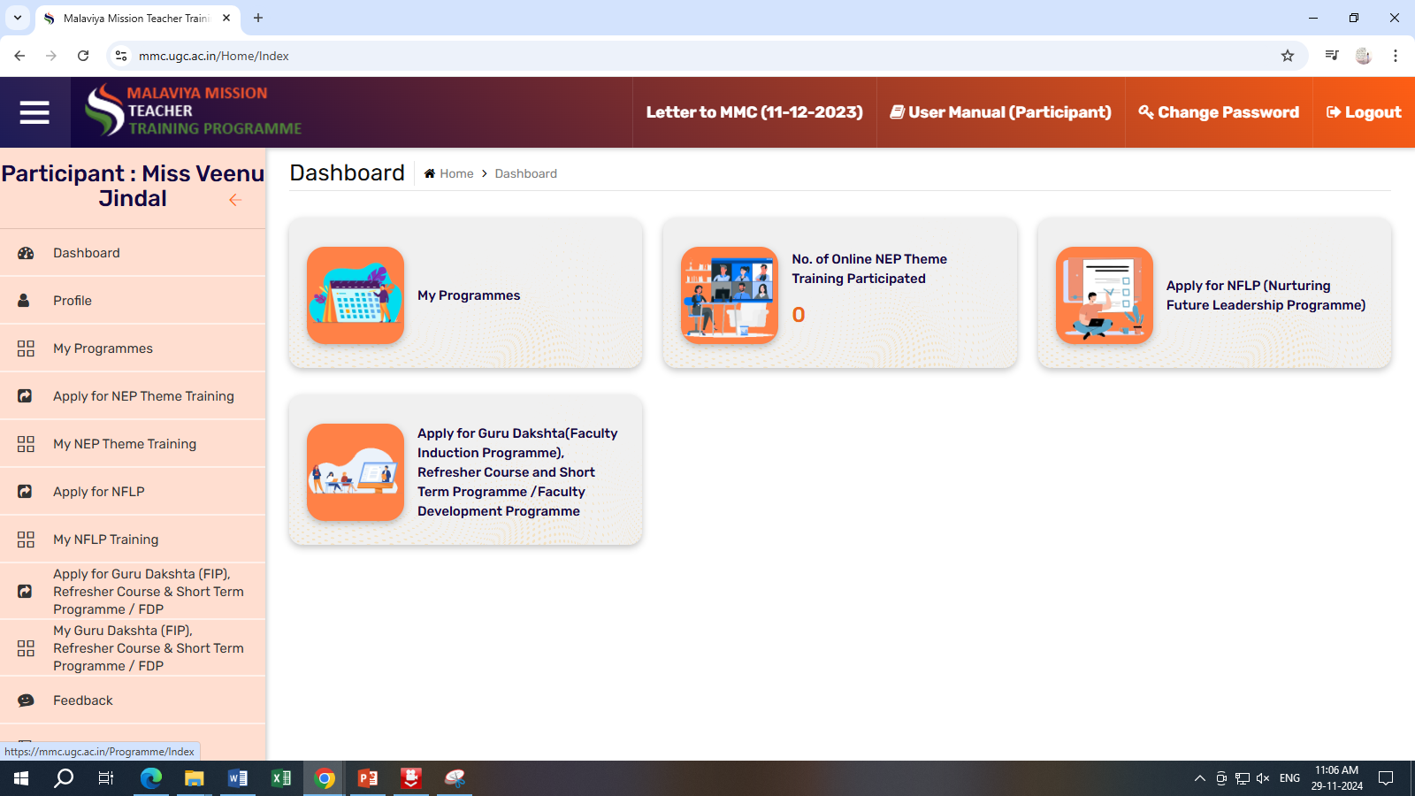

Step 6: Select Apply for “Short Term Programme/Faculty Development”
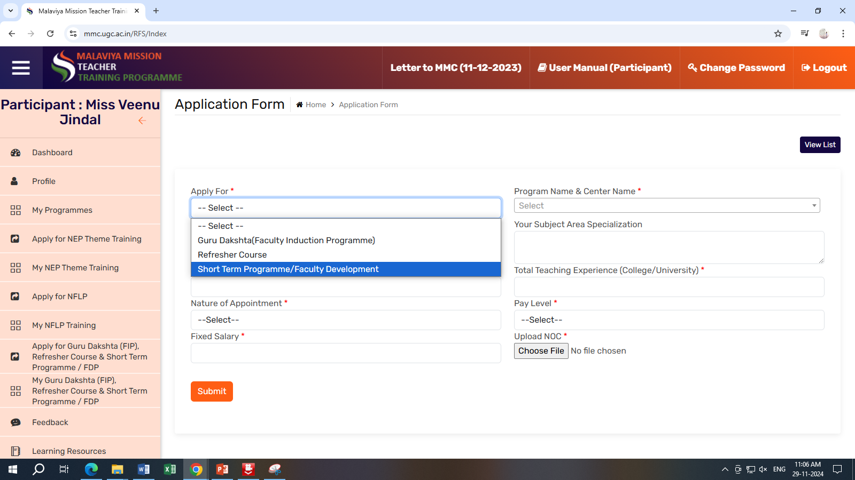

Step 7: Select Programme Name & Centre: “Central University of Punjab (13/01/2025 – 18/01/2025)”
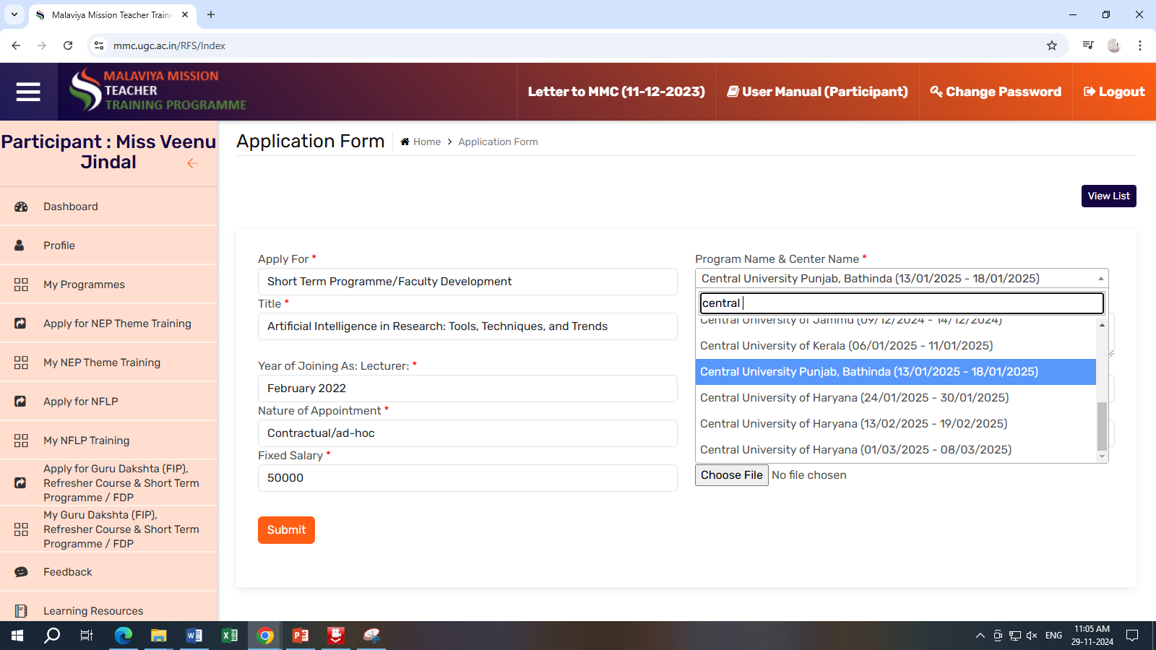

Step 8: Select the Title: “Artificial Intelligence in Research: Tools, Techniques, and Trends” and also basic details like
- Your Area of Specialization
- Year of Joining as Lecturer or Assistant Professor
- Total Teaching Experience (Only College/University)
- Nature Appointment (Pernament or Contractual/ad-hoc)
- Pay Level & Fixed Salary
- Upload NoC Letter with Signature & Stamp, It’s menditory (Format available on Website: https:// cup.edu.in/mmttc )
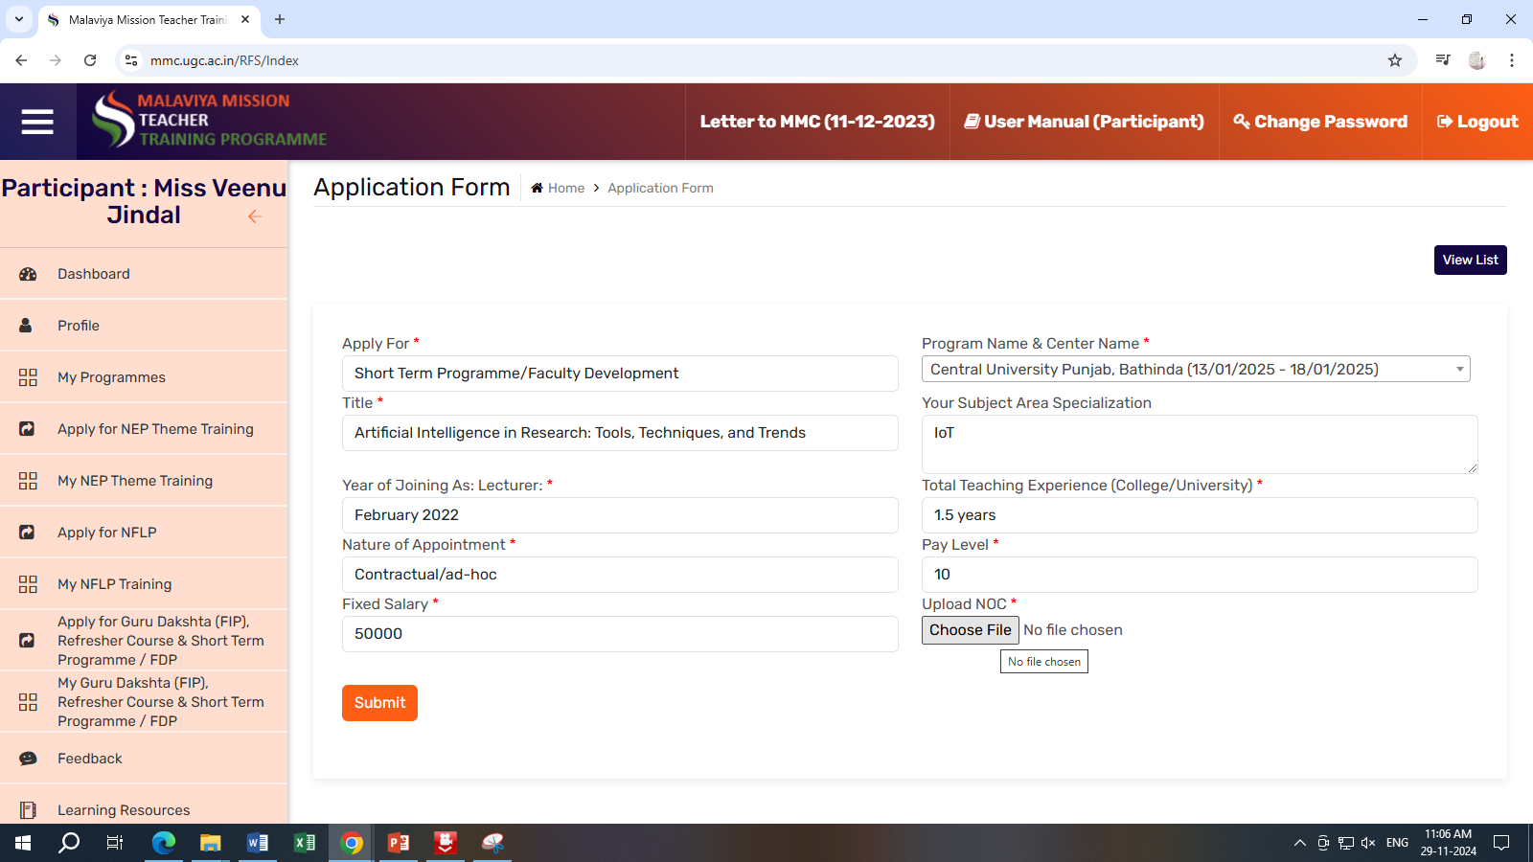
Click on Submit. Then you get Successfully register for this programme.

