User Manual for Refesher Course

Step 1: Registered yourself on https://mmc.ugc.ac.in portal.
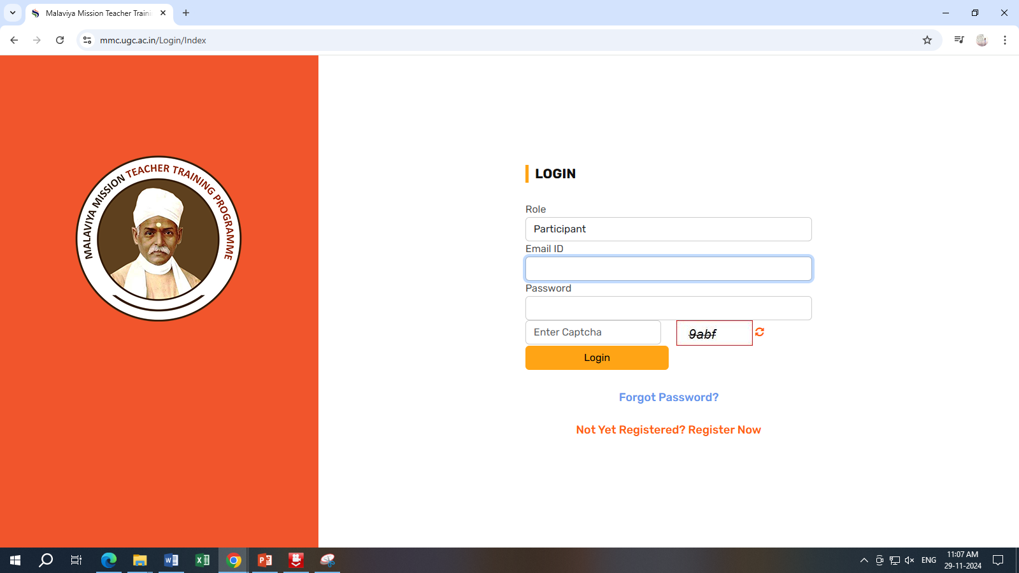

Step2: Enter your details and Click on Submit.
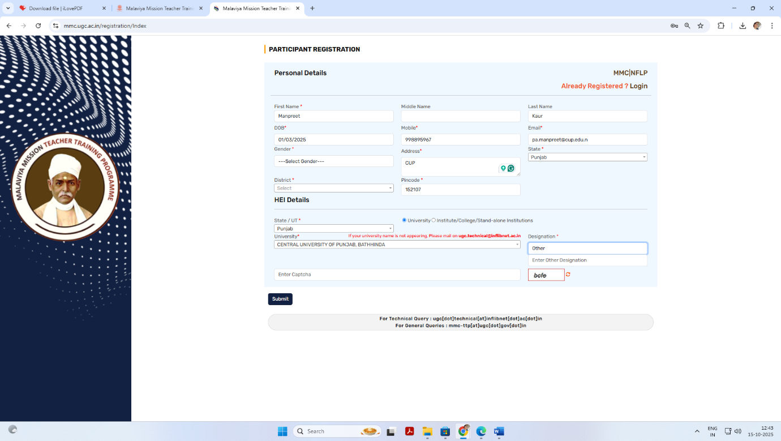

Step 3: Check your email inbox and junk email folder for the username and password, and then change your password.
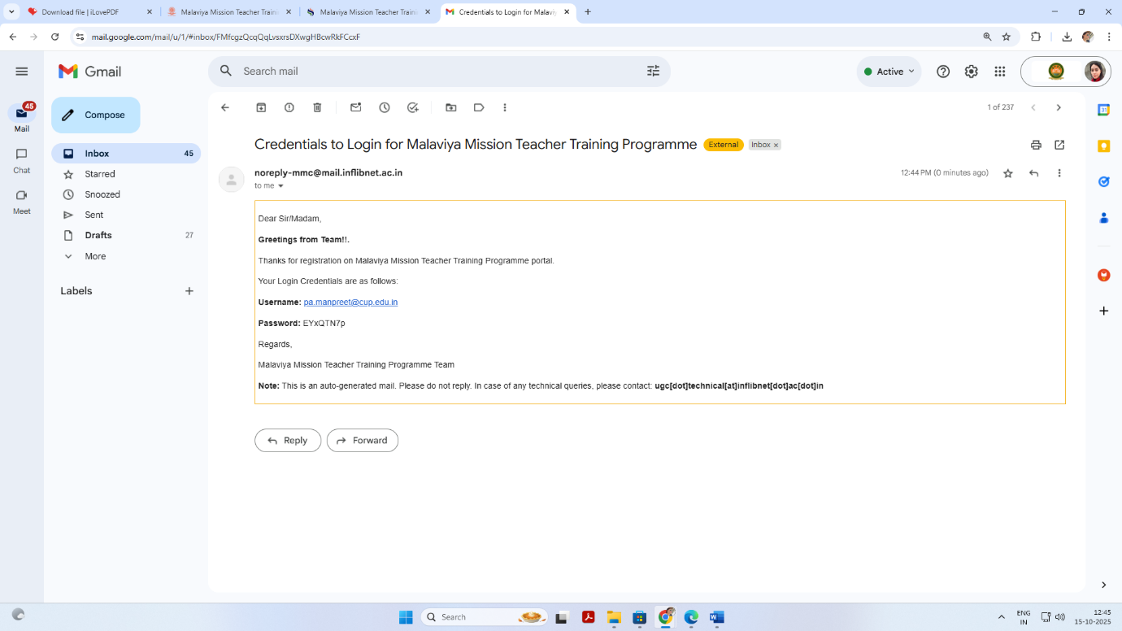

Step 4: Kindly Complete your Profile and Submit.
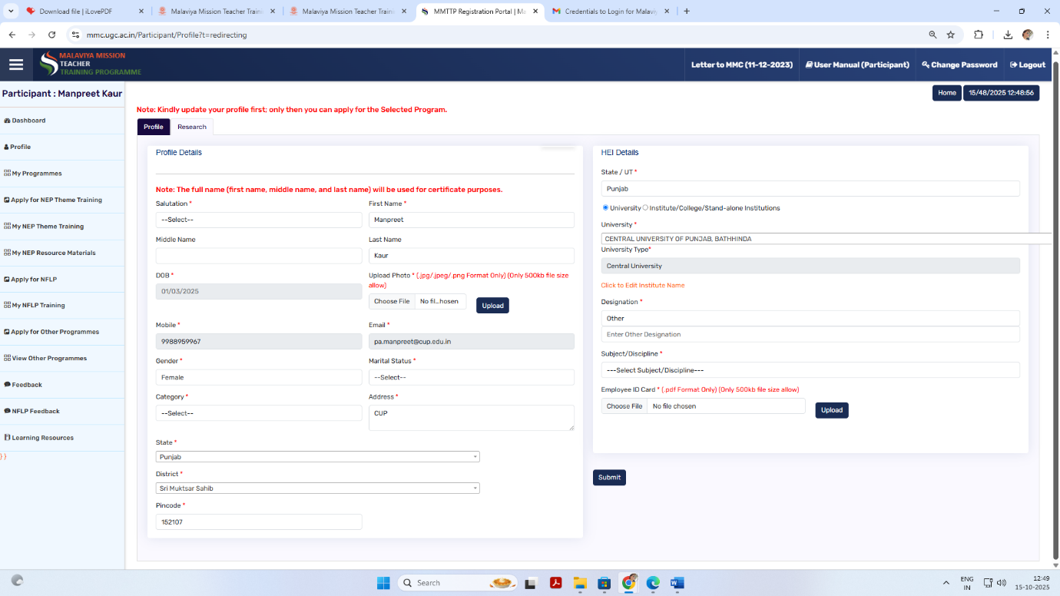

Kindly upload your Photo and Employee ID Card as mentioned above.
It’s mandatory for the applicant in any programme.

Step 5: Select Apply for Refresher course ”
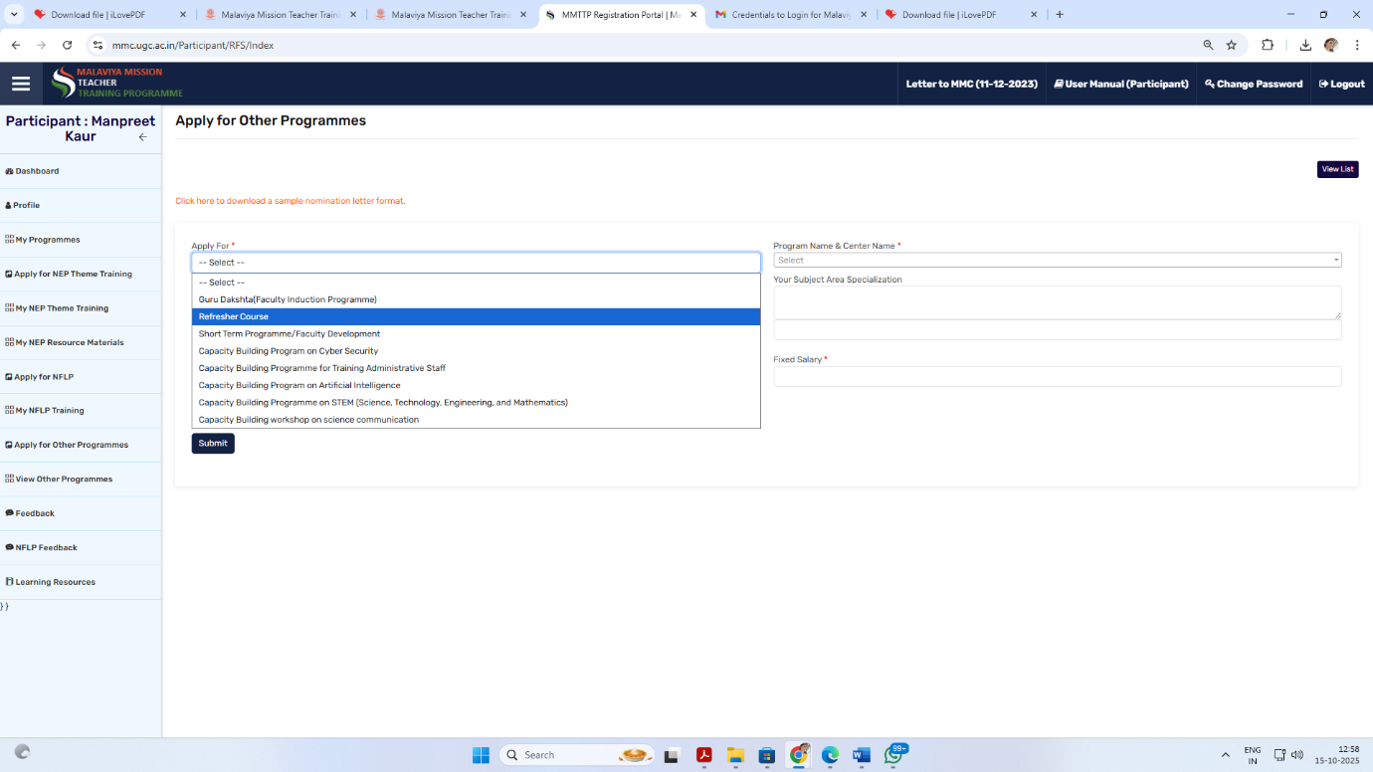

Step 6: Select Programme Name & Centre: “Central University of Punjab (08/12/2025 to 20/12/2025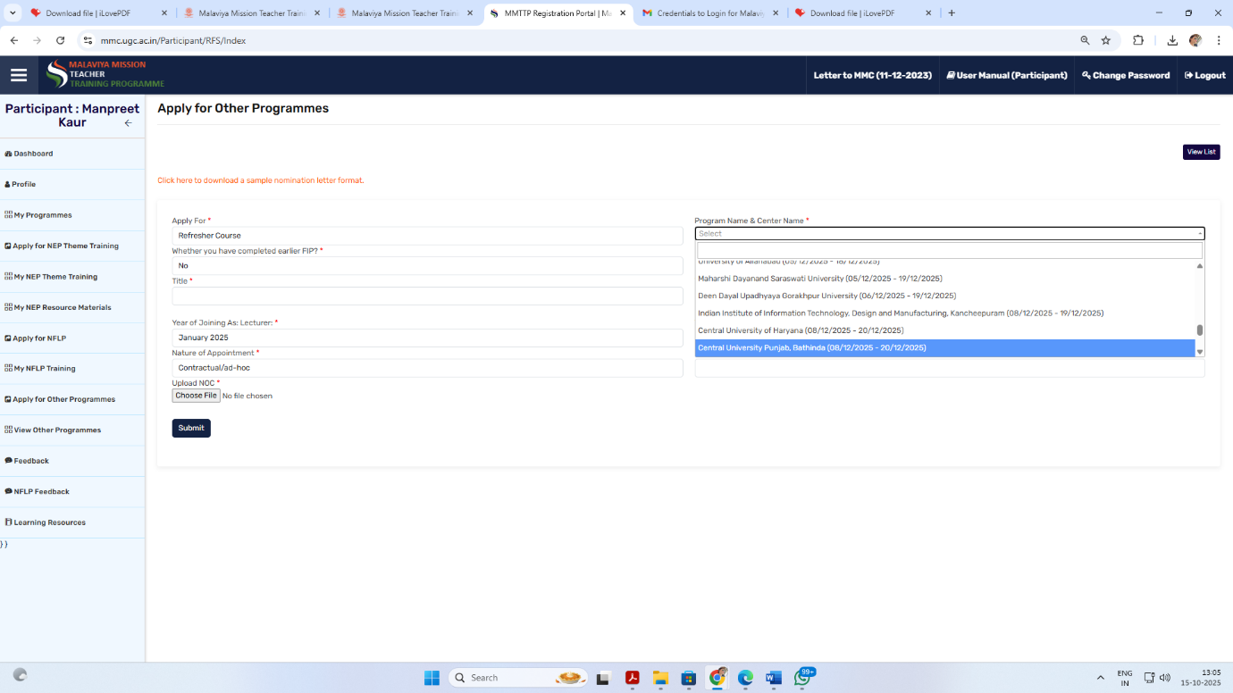

Step 7: Select the Title Smart Information System AI in Action and and also basic details like
- Your Area of Specialization
- Year of Joining as Lecturer or Assistant Professor
- Total Teaching Experience (Only College/University)
- Nature Appointment (Permanent or Contractual/ad-hoc)
- Pay Level & Fixed Salary
- Upload NoC Letter with Signature & Stamp, It’s mandatory (Format available on Website: https:// cup.edu.in/mmttc )
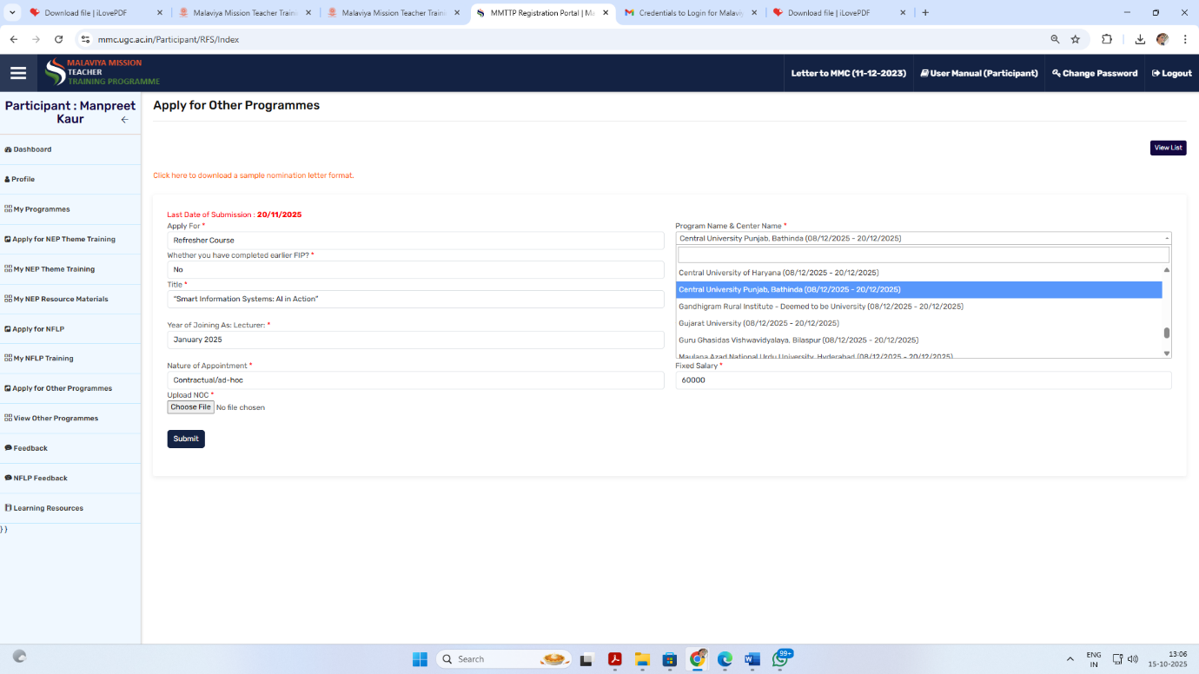Click on Submit. Then you get Successfully register for this programme.

